**LAB 07 ABSTRACTION FUNCTIONS AND REP INVARIANTS**

**Task 1:** **MUSIC PLAYER SYSTEM**

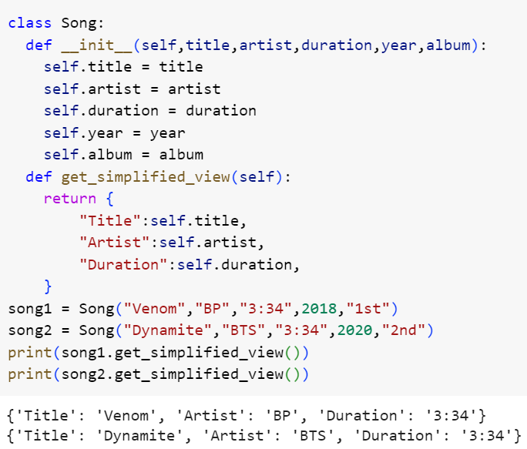

**Task 2:** **VEHICLE MANAGEMENT SYSTEM**

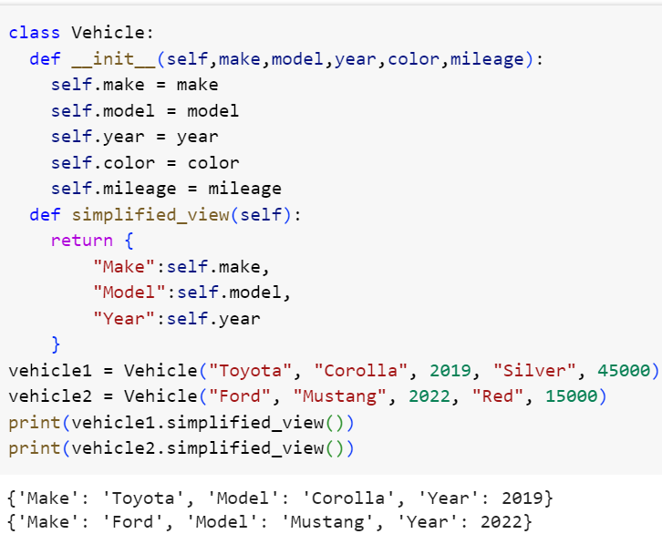

**Task 3: E-COMMERCE PRODUCT LISTING**

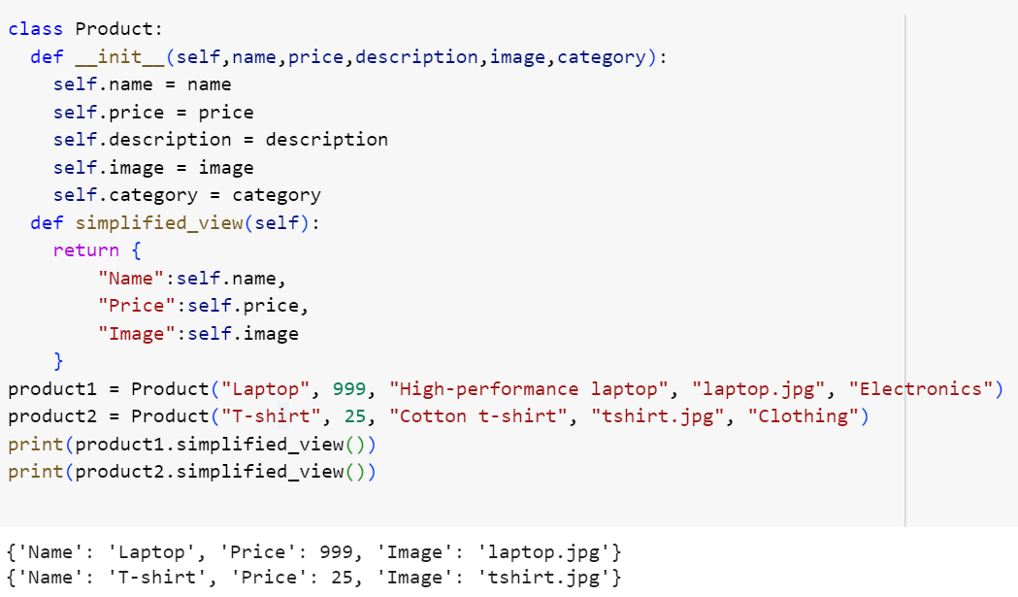

**Task 4: LIBRARY BOOK MANAGEMENT**

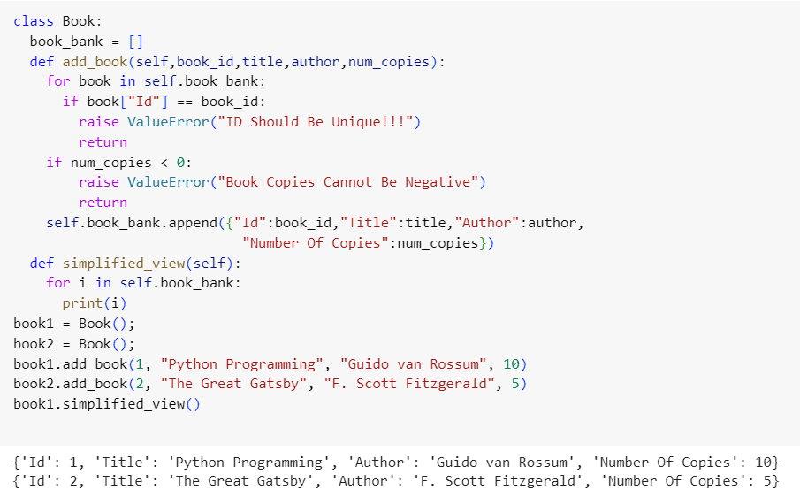

**Task 5: UNIVERSITY STUDENT REGISTRATION**

